Defraser

Basic User Guide

DRAFT

29 December 2011

Zeno Geradts, NFI
Rikkert Zoun, NFI
Marije Huis in ‘t Veld

Introduction

This document gives an overview of the possibilities and usage of the latest release of the MPEG-1 and MPEG-2, AVI, MPEG-4, and 3GP media recovery tool for Windows named Defraser. Note that the tool is a work in progress and is provided as is. H264 is also available as plugin (price on request) Future versions are planned to include further improvements to effectiveness, flexibility and ease of use, as well as support for other file formats, such as Matroshka and JPEG. The user should always check if a certain solution is forensically correct, using other means. This tool is meant as an aid for analyzing media files.

Purpose of the tool:
To find media fragments in files and save these as a playable media file. The source file can be, e.g.:
- a damaged media file
- a (partial) image of a hard drive

Method used:
Basically, the tool is a linear data parser that searches for bit sequences which are characteristic for video data streams. The findings are further processed and classified with a set of decision rules for classifying the findings, and a graphical user interface allowing further analysis and processing.

The following chapter will deal with a step-by-step explanation of all actions involved in the media recovery process. This manual is a basic introduction to the use of Defraser.

Using the tool

The tool can be downloaded from http://sourceforge.net/projects/defraser/. A version supporting H264 is available from the NFI on request. For more information contact: rikkert@holmes.nl or zeno@holmes.nl.

The tool opens with the screen shown below (Figure1).

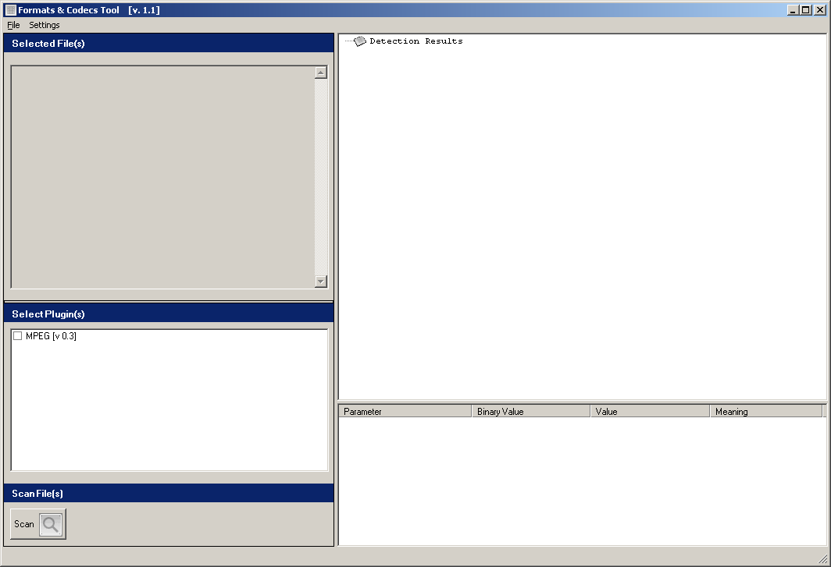
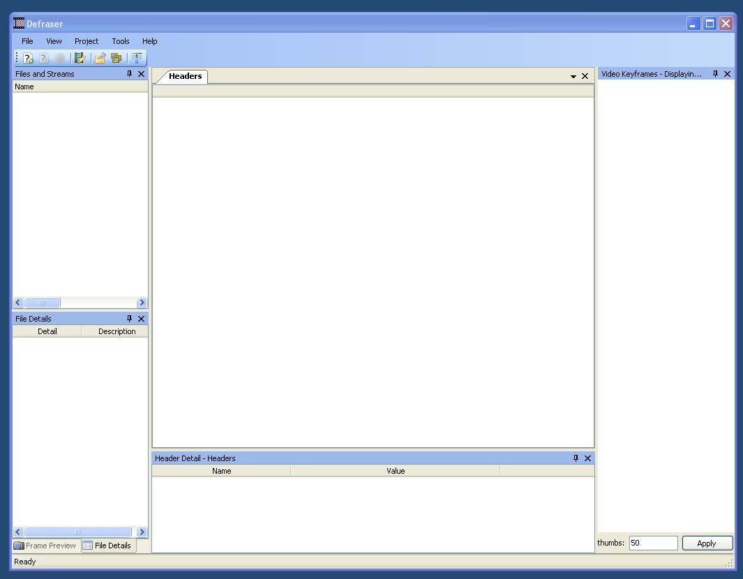
Figure 1

The results are presented in a ‘Tree View’, very much like the Windows Explorer. Navigation through sublevels is done by expanding. First a project needs to be opened, by File – new project, and the project can be opened. The file is dragged and dropped in the headers-screen. The user can select the container detectors and the codec detectors that are appropriate. Also, a keyframe overview can be shown after scanning, by selecting the option as in Figure 2.

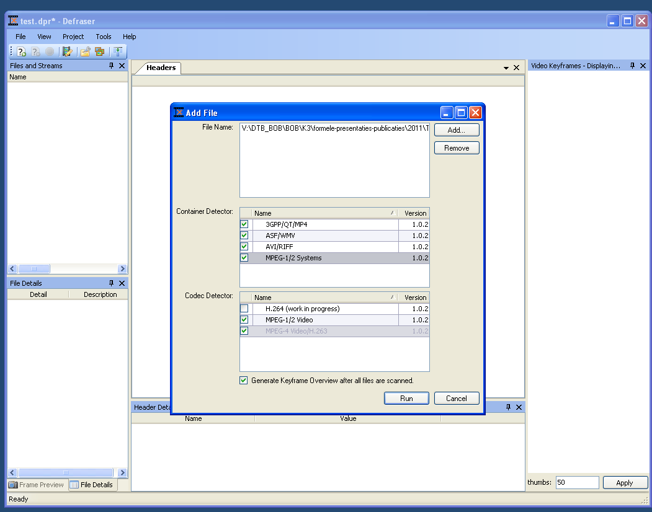
Figure 2

The software will display the keyframes (if available), and the container formats found, if appropriate, as is shown below. When clicking in the Name screen the information can be expanded ,showing the different formats that are analyzed. The Headers screen information shows information on the slices, pictureheaders and other information for the format. In the Header Detail screen more information is given on the selection made in the Header screen.
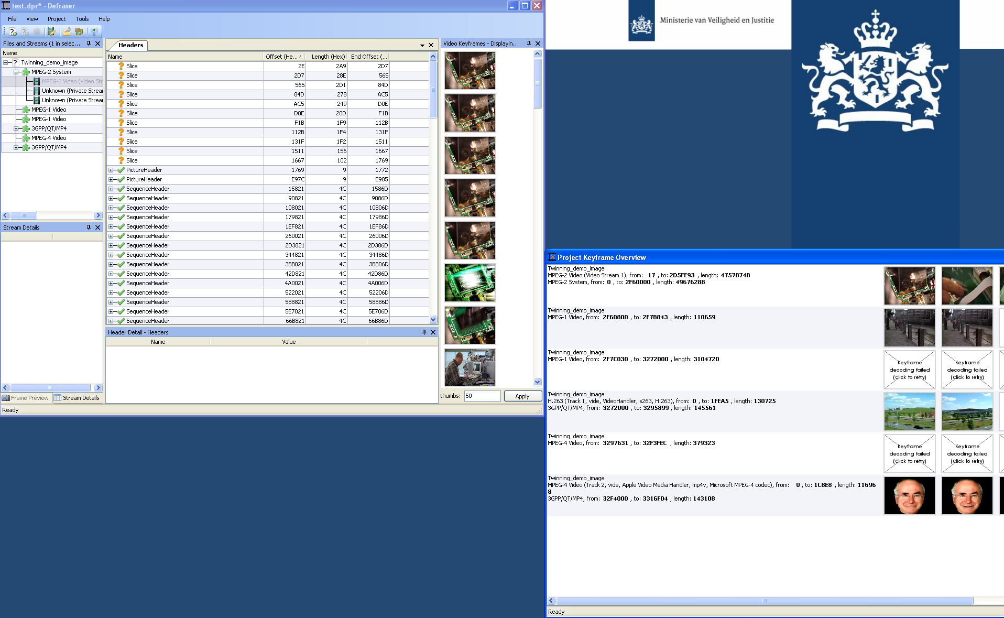
Figure 3

Clicking on the right button of the mouse will provide more options, for example the possibility to send selections to a new workpad or other players installed (VLC player is commonly used by us) or sending it to a Hex editor (Figure 4).

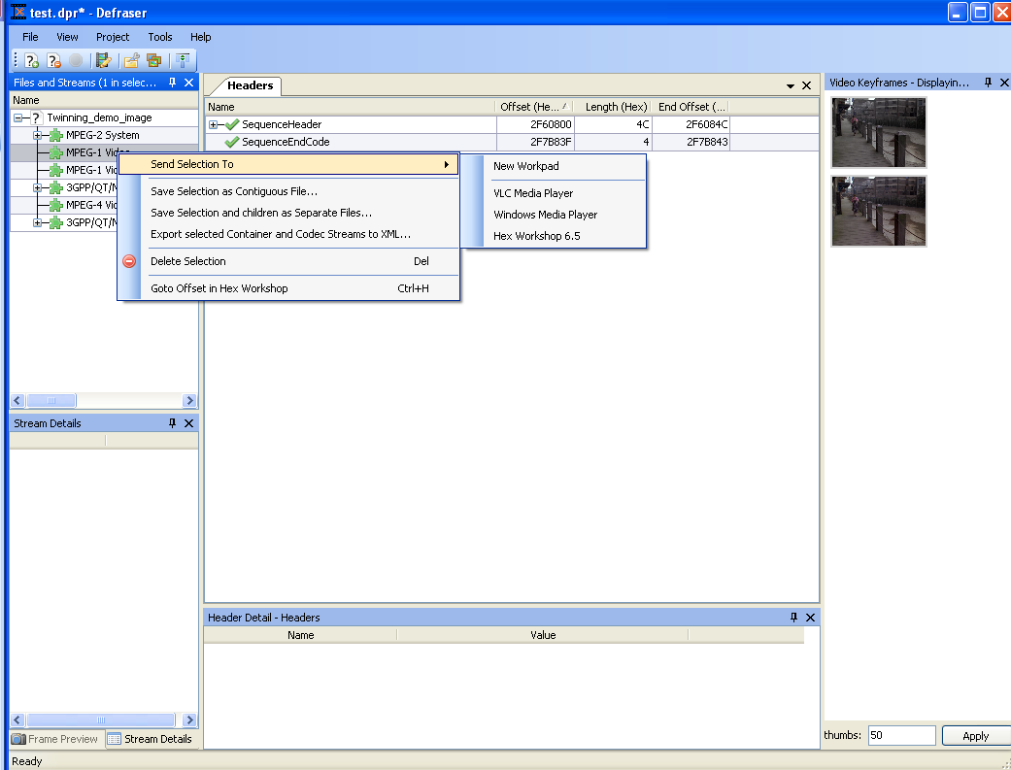
Figure 4

The header details can also be analyzed by selecting them, more information available on the header is shown in the Header Detail box (Figure 5).
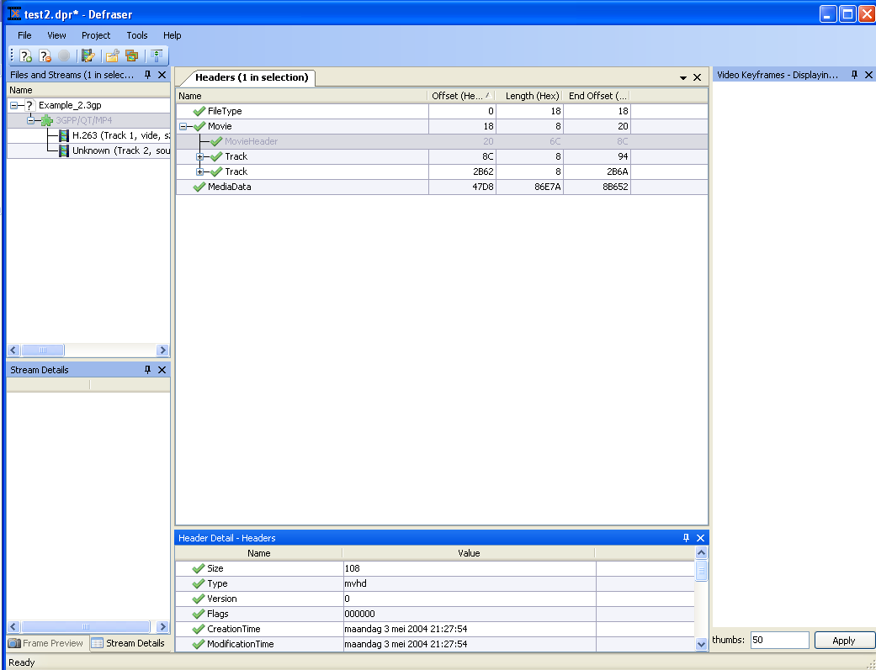

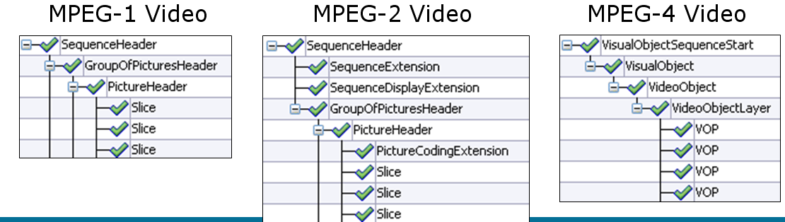
Figure 5

Video formats are organized as shown in Figure 6. With Defraser, the user can make a selection, and send this to a workpad within Defraser to process it.

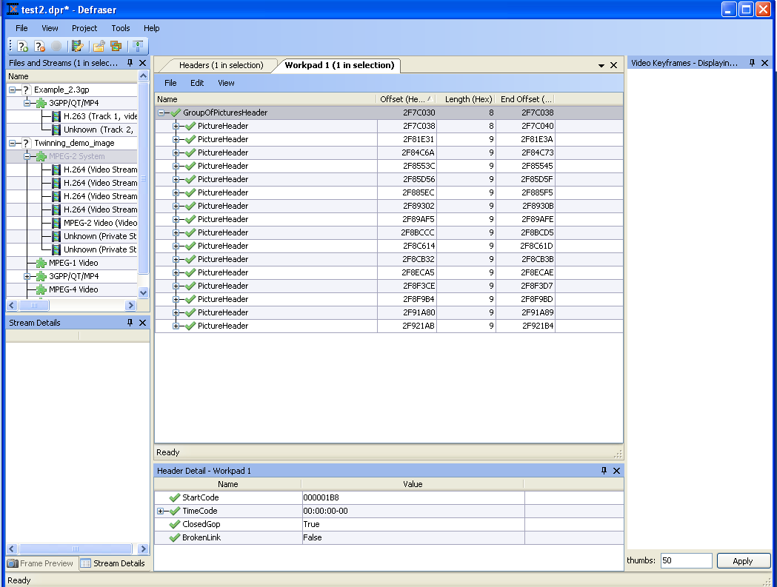
Figure 6

If the keyframe decoding fails due to missing file headers, the user can use reference files (for example from the same device, without missing headers), to repair the video file. The user clicks on the keyframe decoding which failed and subsequently clicks the “click to retry” button in the Video Keyframes screen. The user can then select one of the reference files, which have been analyzed earlier in this project (Figure 7).

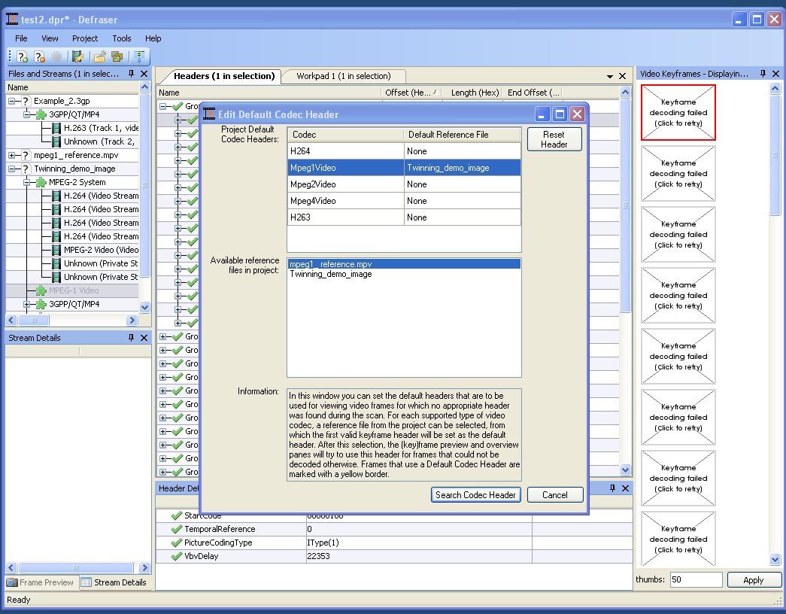
Figure 7

If the appropriate headers are found the file will be playable again. This process can also be done manually within the workpad, selecting the headers of reference files, however in this version it is automated.

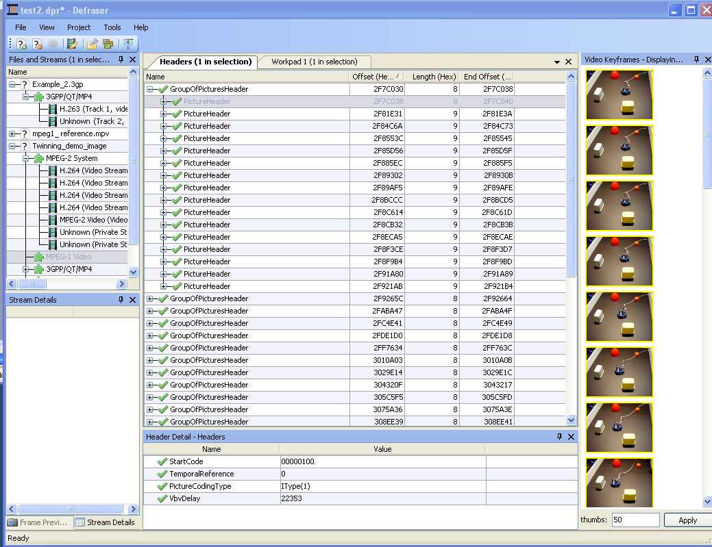
Figure 8

Since file formats can have many properties, the user can opt for showing more or different properties, by selecting the header column chooser under View.

The user can select for a detailed forensic log under Tools, Options.

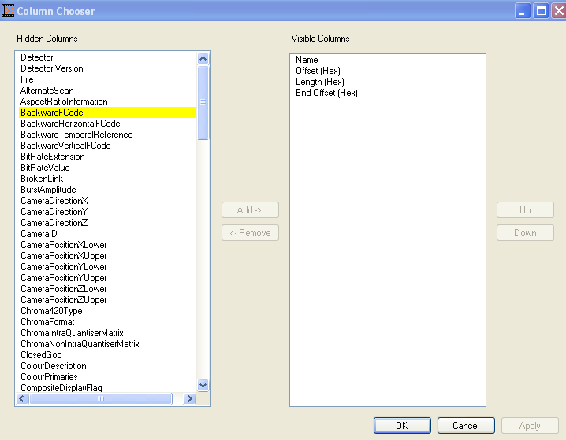
Figure 9

H264 plugin – optional

The H264 plugin can be used in the same way at the other plugins. There one additional feature. If the headers do not contain enough information, the option Convert to H.264 byte stream is visible. This will change part of the information in order to make the stream playable. The exact changes in the file can be logged by using Save Selection As (Figure 9). In the directory where the file is save to, an Excel-file will be created to monitor the changes that are made in order to make it playable.

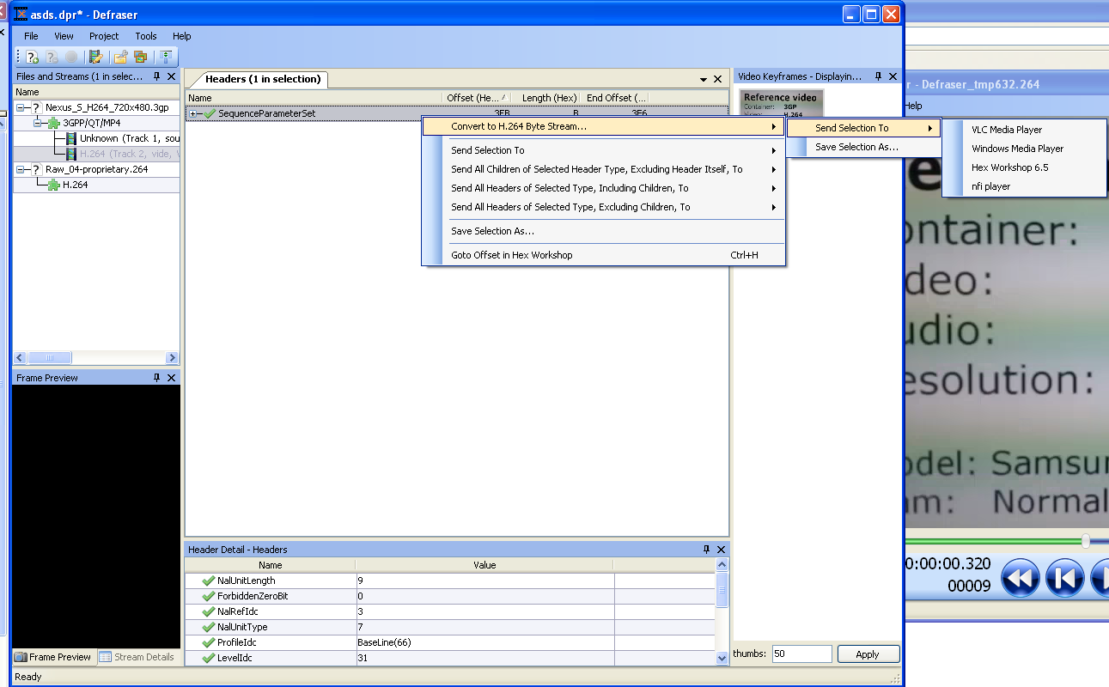
Figure 9

Training

Many more options exist within Defraser however, within this introductory manual only the main features of Defraser are described. To help users working with Defraser. NFI can provide workshops of Defraser to government agencies on request (price upon request)..

